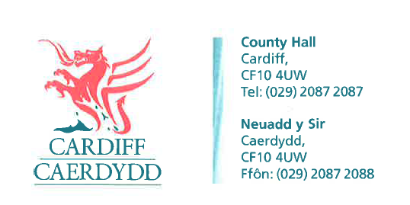
FOI Response Document

FOI 06642

Thank you for your request under the Freedom of Information Act 2000 about Non domestic rate balances received on 14th April 2015.
Your request asked for

I would like a full list of businesses that have become liable for the non domestic rates on a property between the 1st April 2015 to the 15th April 2015. Including the business name, address, type of property and the date they became liable please

RESPONSE: Under Section 21 of the FOIA we are not required to provide information which is already reasonably accessible to you. The information you have requested is available from City of Cardiff Council’s publication scheme.
Please find below the link to the Councils Publication Scheme, Business Rates page held on the Council’s Internet site:
https://www.cardiff.gov.uk/ENG/Your-Council/Data-protection-and-FOI/Freedom-of-information/Publication-scheme/Pages/Publication-scheme-business-rates.aspx
This information is covered in Lists 2 & 3 and is updated quarterly.

If you have any queries or concerns, please do not hesitate to contact us.
Please remember to quote the reference number above in any future communications.
:

